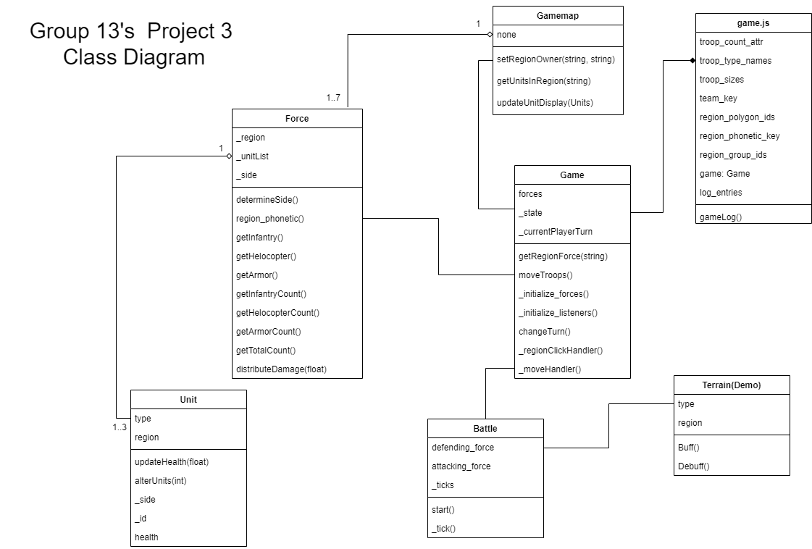

The design pattern fits the best with our design pattern for this project is Mediator. A mediator is a design pattern that helps reduce dependencies between objects such that the pattern prevents direct communication between the objects. The Game object as the mediator for this project. Additionally, the game has a connection with the gamemap, battle, and force separately. However, these objects are forced to communicate only by a mediator object which is the Game object. Since the Game as the mediator, it helps the other objects communicate with each other such as moving the forces between regions, calling battle when two forces of different side arrived on a region, etc based on the inputs of players handled by html and svg. The inputs of the players allows the Game object to interact without any errors as it handles all the classes. It allows for the game to flow smoothly and allow for game to operate properly. Also if the user decides to combine forces and this game object allows the user to combine troops and attack properly on the enemy forces allowing a user to win more easily if they decide to combine forces. The Game object or Mediator allows for less chaos in the code and makes the implementation more efficient for how the game is designed. The mediator is a very good pattern for how our game is designed and allows us to develop it the best way possible.